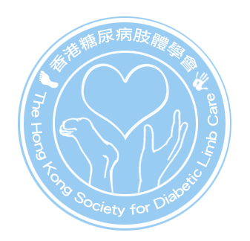
香港糖尿病肢體學會
The Hong Kong Society for Diabetic Limb Care
c/o LG1 Block K
Queen Mary Hospital
102 Pokfulam Road Hong Kong
Fax 2255 3800 E mail enquiry@diabeticlimb.hk

Registration for Annual and Extraordinary General Meeting
Date of AGM and EGM : Friday May 28, 2010 in Kowloon

Venue : To be confirmed

Time | Topic
6:30pm-6:45pm | Registration
6:45pm-7:15pm | EGM
7:15pm-7:45pm | AGM
7:45pm-9:45pm | Annual Dinner

Registration procedures: Please keep the bank slip until confirmation available at home page

- Complete the following form (deadline: May 10, 2010)
- Deposit $200 each member into The Hong Kong Society for Diabetic Limb Care’s account at Bank of China no. 012 916 110 808 79.
- Mark your Full name in block letter and contact tel, e-mail or fax no. on the bank slip
- Fax or e-mail the form and bank slip together to HKSDLC at 2255 3800

Confirmation of registration: upon completed of faxing or e-mail the completed registration form together with the bank slip to HKSDLC, your registration is confirmed and NO fee will be refunded. The list of confirmed registration will be available at www.diabeticlimb.hk, not later by May 18 2010.

Receipt for the payment: issued upon your signing at the registration desk of EGM and AGM.

Registration Slip

From (Name) _______________________ To: HKSDLC (Fax: 22553800)

Membership No.: ________________ Tel no. : ______________ Fax: _________________
Unit/Hospital : ________________
I will attend ; (Please tick in the appropriate.)

- EGM and AGM ( )
- Annual Dinner ( )

The end

