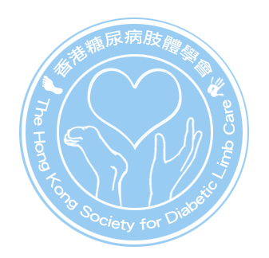
香港糖尿病肢體學會
The Hong Kong Society for Diabetic Limb Care

Dear Members,

NOTICE OF GENERAL MEETING

We would like to announce that The Society will hold Annual General Meeting (AGM) and Extraordinary General Meeting (EGM) on 28th May 2010. Details of the meeting are described on the Notice of Annual General Meeting and Extraordinary Meeting.

You are cordially invited to attend the AGM and EGM. After the meeting, the Society is organizing annual dinner. The cost of dinner is HK$200 per person. To facilitate the seating and dinner reservation, we would like you to confirm your attendance before 10th May 2010.

We would like you to complete the registration form if you attend the meeting and annual dinner. Details of registration are described on the registration form. If you are unable to attend, please complete the Proxy Form. Details of Proxy are described on the Notes on Proxy Form.

We attach the following documents for your action.

1. Notice of Annual General Meeting;
2. Notice of Extraordinary General Meeting; and
3. Registration Form

The Society has posted the Invitation to attend 2010 AGM and EGM on the Society website: http://www.diabeticlimb.hk/main.php

We look forward to seeing you at the Meeting.

Yours truly,

Hui, Lan Fong
Secretary of The Hong Kong Society for Diabetic Limb Care

